



**IS480 Project Proposal**

**Stepwise**

**The Grizzly Badgers**

**v1.1**

**11 October 2016**

**Team Members:**

* Christopher Teo Jian Ming ([mj.teo.2014@sis.smu.edu.sg](mailto:mj.teo.2014@sis.smu.edu.sg)) - Project Manager & Business Analyst
* Yu Zheng Yuan ([zyyu.2014@sis.smu.edu.sg](mailto:zyyu.2014@sis.smu.edu.sg)) - Data & System Analyst
* Lam Zhao Yin Aloysius ([aloysiuslam.2014@smu.edu.sg](mailto:aloysiuslam.2014@smu.edu.sg)) - Front-end Developer
* Abdul Shahid Bin Rahmat ([abdulsr.2014@sis.smu.edu.sg](mailto:abdulsr.2014@sis.smu.edu.sg)) - Front-end Developer & Database Specialist
* Ang Zhuang Kai Friedemann ([zk.ang.2014@sis.smu.edu.sg](mailto:zk.ang.2014@sis.smu.edu.sg)) - Back-end Developer & Database Specialist
* Wu Jiawei Jason ([jason.wu.2014@sis.smu.edu.sg](mailto:jason.wu.2014@sis.smu.edu.sg)) - Back-end Developer

**Faculty Supervisor:**

* To be Assigned

**Sponsor:**

* Ang Mo Kio Thye Hua Kwan Community Hospital
  + Mr Damien Tong ([damien_tong@amkh.org.sg](mailto:damien_tong@amkh.org.sg)) - Human Resource Director
  + Mr Edy Chandra ([edy_chandra@amkh.org.sg](mailto:edy_chandra@amkh.org.sg)) - Systems Analyst
  + Dr Jocelyn Koh (jocelyn_koh@amkh.org.sg) - Infection Control Team Lead
  + Ms Sarah Lim (sarah_lim@amkh.org.sg) - Infection Control Team

**Project Overview**

**1.1 Project Description:**

Ang Mo Kio – Thye Hua Kwan Hospital (AMKTHKH) currently uses a legacy system developed for Visitor Logging known as the “Triage System”. The hospital wants to replace this system with one which is more robust and keeps manual recording to a minimum. The Triage System is deployed during states of medical emergency such as the outbreak of a highly contagious disease, to provide a contact list of people who have come in contact with infectious visitors or patients.

**1.2**  **Motivation:**

Visitor logging in AMKTHKH presently happens through a fairly tedious and unreliable process of manual recording. Due to the limited exposure of the recording system to the business process, important data points are missing, such as dwell time and location of visit. This negatively affects the data available for use in contact tracing when an infectious person has been identified. We aim to streamline, simplify, and increase tracking, so that contact tracing can be more accurate and effective.

Our X-Factor is to successfully record the visited ward, and time of departure for at least 75% of all visitors to the hospital.

**1.3 Stakeholders:**

|  |  |
| --- | --- |
| Sponsor | The Infection Control Team and IT/MIS Team will be our main stakeholders in this project. The Infection Control Team will be providing us with Ministry of Health Regulations and information as well as a low-down of their processes related to visitor logging and contact tracing. The IT/MIS Team will be providing advice and information on the current system architecture of AMKTHKH. They will also be our primary point of contact from AMKTHKH, for the coordination of meetings and user testing sessions. |
| User | The front desk personnel such as Nurses will be using this system to manage the registration and sign in of visitors. The Infection Control Team will be using this system to access visitor records for contact tracing purposes. Finally, the IT/MIS Team will be maintaining the system, related to the tracking function, and management of passes and visitor records. |
| Advisors/ Practitioners/Mentors | IT/MIS System Analyst, Edy Chandra, will be working with our team with regards to the IT requirements of our project. |

**1.4 Deliverables:**

*Outcomes*

A Web-based application hosted on a local server managed by IT/MIS, which is able to take in and store visitor information such as personal particulars, medical history, travel history and visit information. The visit information of all visitors will be accessed in events where contact tracing is initiated to identify all visitors who have been in contact with an infected visitor or patient.

*Value Statement*

The sponsor will obtain an integrated solution for visitor tracking, visitor logging, and contact tracing.

**1.5 Scope:**

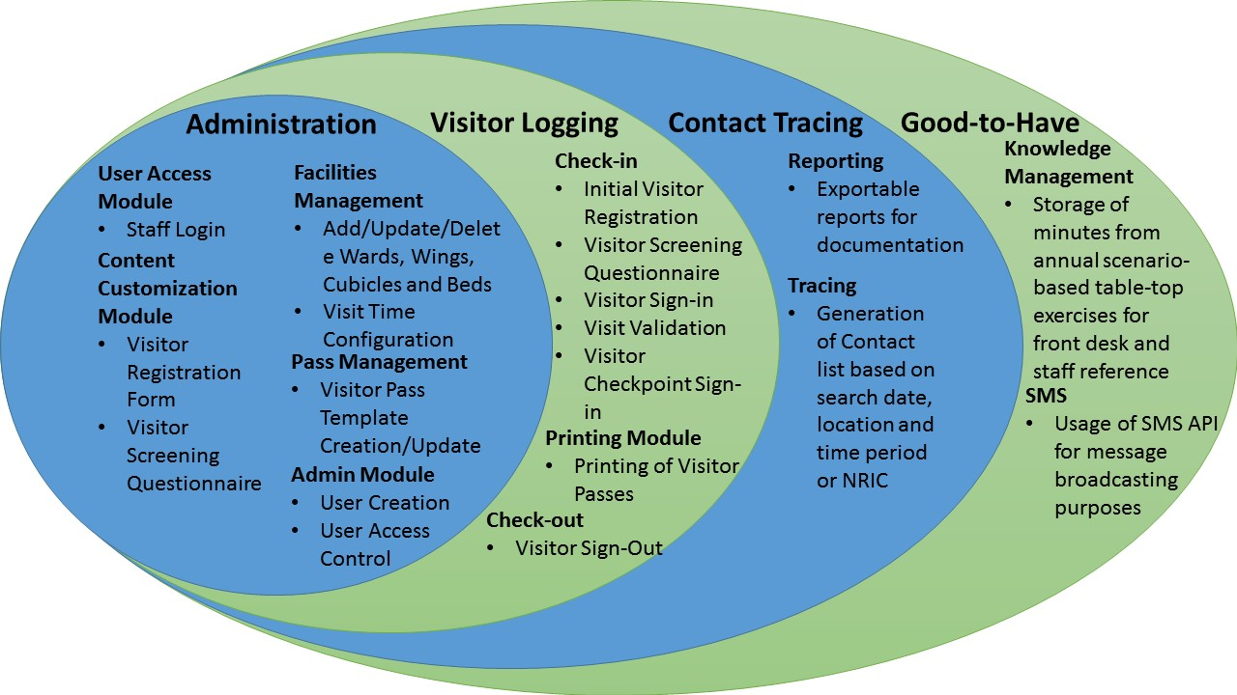

In-Scope Requirements

|  |  |
| --- | --- |
| **Must-Haves** | **Good-to-Haves** |
| * Visitor Logging * Visitor Tracking * Contact Tracing * Administrative configuration functions | * Knowledge Management Function to refer to SOPs or FAQs * SMS System for information broadcast to visitors or staff |

Constraints

* Existing Infrastructure at AMKTHKH will restrict the flexibility of programming to .NET architecture.
* Local nature of the AMKTHKH server would limit the time available for on-site testing of the application.

Assumptions

* The visitor logging and admin modules will be built before the contact tracking module to allow for logic testing of the logging process which the contact tracing module is based on

**Project Plan**

**1.6** **Project milestone:**

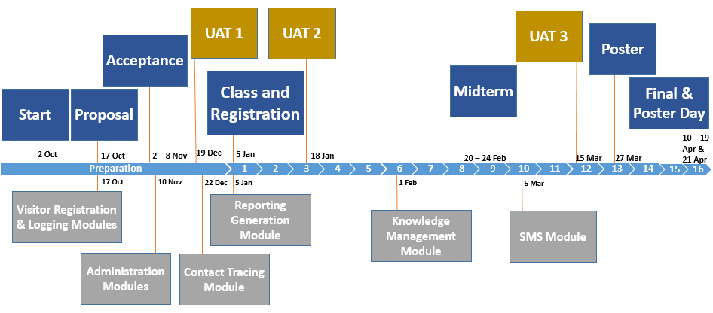

**1.7** **Risks:**

|  |  |
| --- | --- |
| **Risk** | **Mitigation** |
| Potential Difficulty in programming in C# as some of team members are not experienced in C#. | Plan out a timeline to learn & practice programming in C#. Also work with IT/MIS from AMKTHKH on this as they are proficient in .NET programming languages |
| Lack of Change Management Process | Team to define a Change Management process & share it with the Client & Supervisory Team |
| Impacted Stakeholder are ill-informed of progress | Team will update the advisor fortnightly via email on the progress of the development |
| Verification against the Patient Management System during go live might fail as we cannot verify against real patient data in the development phase due to data privacy issues. | Team will need to verify it during UAT, or when the system is deployed on the production server. |

**1.8** **Resource and references:**

|  |  |
| --- | --- |
| **Training/Library Requirement** | **Source/Training IC** |
| JIRA Project Management Tool | Christopher Teo |
| Git Repository Version Control Methodology | Friedemann Ang,<https://help.github.com/articles/using-pull-requests/> |
| .NET (C#) | Shahid Abdul Rahmat |
| HTML/CSS/Javascript | <http://www.w3schools.com/> |